 | Points | ELAR | History | Math | Science | Comments
Essential Question  Must have correct punctuation | 2
Vocabulary/key terms are  Circled | 4
Main ideas are chunked | 4
Main ideas are highlighted or underlined | 3
Level 2 or 3 questions on left side of paper to match chunking.  MUST be level 2 questions to receive credit (3 points each) | 9
3 sentence summary with correct capitalization, punctuation and grammar. | 3
Learning Logs (25 points)
- Count sentences—must have 3 complete sentences for #1-4
- 1 question/statement for #5
Each number is worth 5 points
Total Grade | 100
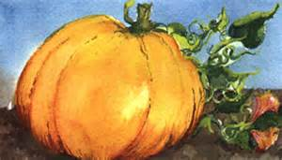
Name __________________________________________ AVID Period ______Q1
Cornell Note Rubric
Date: _____/________/2016

Evaluator’s Name _____________________________________________________________________

