Math Homework Due 2-13-14 Name________________________________
Please watch the video and complete this paper.

- A vertex is ________________________________________________________
Example Non-example

- A face is _________________________________________________

Example Non-example

- An edge is _________________________________________________

Example Non-example

We are starting something new with our facts. This week you only need to practice your 5’s. On Friday you will have a fact fluency test. If you beat the time and number correct you will get 100 Starbucks from your teacher. If you meet every goal for a month then you will get the mystery prize. There will be a new prize every month! Start practicing.
Monday | Tuesday | Wednesday | Thursday

Figure | Examples |  |  | Attributes
Rectangular Prism |  |  | ___ rectangular faces  ____ edges  ____ vertices
Cube |  |  | ____ square faces  ____ edges  _____ vertices
Square Pyramid |  | 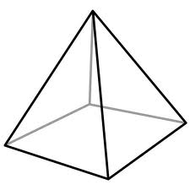 | _____ square face  _____ triangle faces  _____ edges  _____ vertices
Cone |  | 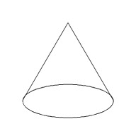 | ____ circular face  ____ edges  _____ vertices
Cylinder |  |  | ____ circular faces  ____ edges  _____ vertices
Sphere |  | 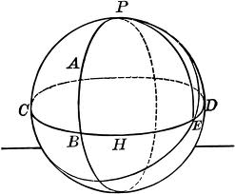 | ____ faces  ____ edges  ______ vertices

Please answer these questions about the volume of a rectangular prism.

- What is the formula for the volume of a rectangular prism or cube?

- The length is ___________________________________________________________________________

- The width is ______________________________________________________________________

- The height is ______________________________________________________________________

To find the volume of a rectangular prism you need to multiply length x width x height.

- Find the volume of the following figure.
4
5
12

- Find the volume of the following figure.
7
6
13

