Identify each angle.

1. 2. 3.

______ ______ ______

Identify each line type

4. 5. 6.

______ ______ ______

Mark each shape as a polygon or non-polygon

7. 8. 9.

______ ______ ______

10. 11. 12.

______ ______ ______
Name____________#_______ Date______

This week you only need to practice your 4’s. On Friday you will have a fact fluency test. If you beat the time and number correct you will get 100 Starbucks from your teacher. If you meet every goal for a month then you will get the mystery prize. There will be a new prize every month! Start practicing.

Monday | Tuesday | Wednesday | Thursday

Fill in each definition and show one example and one non-example. You can draw a picture or write down the examples and non-examples.

Angles____________________________

_________________________________
Non-Example
Example

Polygon ___________________________

_________________________________
Non-Example
Example

Two Dimensional Shape__________________

_________________________________
Non-Example
Example

1. A line of symmetry divides a figure into two __________________________ halves that are _______________________________ of each other.
Example of Symmetry____________________________ Non Example___________________________________

- Circle all the objects that have only one line of symmetry.

- Circle all the objects that have only two lines of symmetry.

- Draw all the lines of symmetry on the following shapes.
6.

Translation = ___________________________________________

Example of translation________________________ Non Example_________________________________
Reflections = ____________________________________________

Example of reflection________________________ Non Example___________________________________
Rotation = _______________________________________________

Example of rotation________________________ Non Example___________________________________
Write TRANSLATION, REFLECTION, or ROTATION for each picture
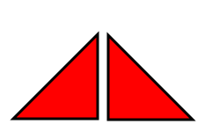
6. 7.

_____________________________ _____________________________

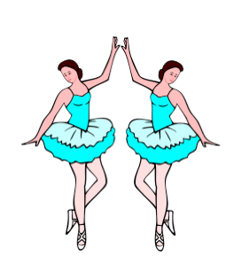
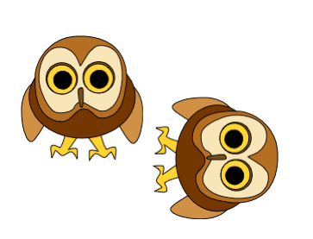

8. 9.

_____________________________ _____________________________

10. 11.

_____________________________ _____________________________

