Traditional Division
Name_____________________________#_______Date_______
Remember to practice your multiplication facts EVERY day! You can find some practice sites on my teacher website. You can practice your math facts in the car on the way to school or on the way to an event. Practice does not have to be more than 5 to 10 minutes a day. If you want to do one day of 20 minutes then note that on your homework.
Monday | Tuesday | Wednesday | Thursday

A dividend is __________________________________________________________________________________________________________
Example Non-Example

A divisor is __________________________________________________________________________________________________________
Example Non-Example

Quotient___________________________________________________________________________________________________
Example Non-Example

Independent practice: 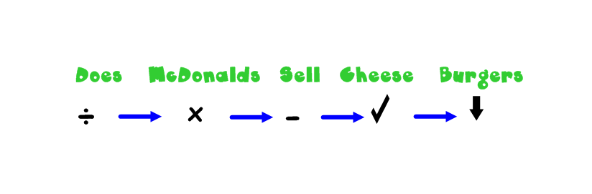
- 54÷2 2. 87÷6 3. 26÷5

4. 862÷3 5. 409÷4 6.550÷5

