Name _________________________________________ pd _______ Date _________________________________
Week 26 Homework: March 16-19, 2015
- Solve for h. You must show work!  $$-2h+23+8h=191$$ | 2. Solve for w. You must show work!  $$7.23w≥404.88$$
3. Solve and round to the ones place.  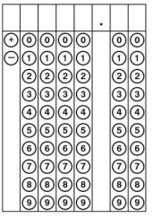  $\frac{1.6(7)}{6}$ - $\sqrt{90}$ | 4. Solve and round to the hundredths place.  $$7^{2}-\sqrt{340}$$
5. Is this a rotation or a translation? Why?  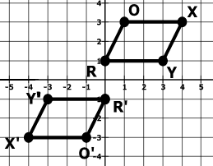 | 6. Andrew needs to clean the window to his house. He places his 20 ft ladder 10 ft away from the house. How high is the window from the bottom of the house?  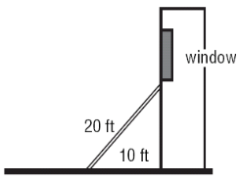
7. If the dimensions of a circle with a circumference of 24 inches are tripled, what will be the circumference of the new circle? (HINT: Scale Factor) | 8. Caitlin invested $520 in to an account that earns 5% simple interest. If she leaves the money alone for 11 years, how much interest will she earn?
9. Convert to scientific notation.  8,900,000,000,000 | 10. Will this be a proportional or non-proportional line?  $$y=-3x+14$$
11. Triangle ABC is reflected over the y axis, what will the ordered pair of B’ be? | 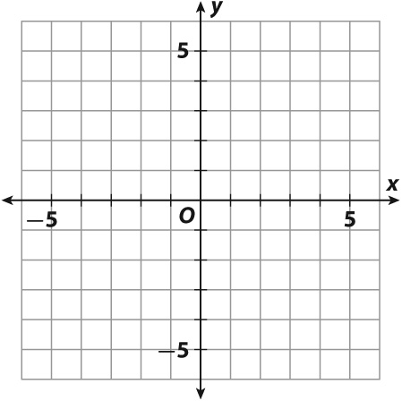  12. What is the distance from B to C?  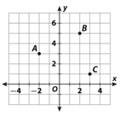
13. The scatterplot shows the relationship between the age of students x and their vertical leap y, what would be a fair vertical estimate for a 15 year old?  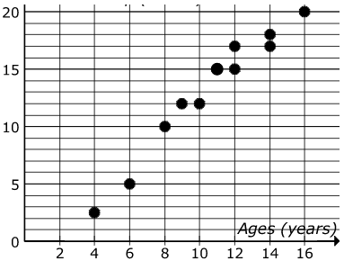 | 14. How much paint would cover the prism below?  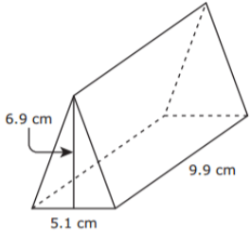  7.4 cm
15. Find the m∠NRQ when m∠NRS  78°.  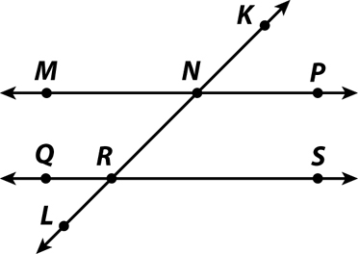 | 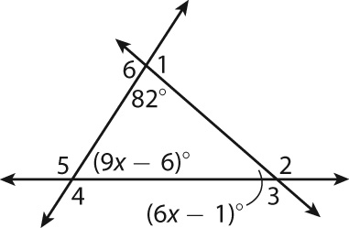  16. Solve for x.
17. Use the below equation to complete the table.  X Y  -12  -5  0  13  y = 12x -5 | 18. Is this a right triangle? Why or Why not?
19. Write the translation rule for left 4 and down 8? | 20. Solve for a.  $$-15+3a=6a+33$$

