World Geography Fall Semester Exam
Pg. 40
- Define Region –
A group of places with at least one common characteristic.
Pg. 41
- What are the three types of Region?
Formal, Functional, Perceptual
- Define Functional Region –
A area consist of an central place and the surrounding places affected by it
- Give an example of Functional Region -
The DFW airport area, Kiss FM broadcasting area
- Define Perceptual region –
An area that is defined by people’s feelings and attitudes about the area.
- Give an example of Perceptual region -
Dixie (The old south)
The upper Midwest
Pg. 45
- Define Lithosphere -
Soil, rocks, landforms, and other surface features
- Define Atmosphere –
layer of air, water, and other substances about the surface
- Define biosphere –
the world of plants, animals, and other living things that occupy the land and waters of the planet.

Pg. 46
- Using the picture of pg. 46, What landform has a flat top with suddenly dropping sides?
Plateau
- What landform has sediment piles up where the river empties into a lake or sea?
Delta
Pg. 48
- What is convection?
The circular movement caused when a material is heated, expands and rises, then cools and falls.
- How is it related to plate tectonics?
Most scientists believe this causes movement in plate tectonics.
- Define Theory of Plate Tectonics –
The earth’s outer shell is not one solid sheet of rock. Instead, the lithosphere is broken into a number of moving plates.
- What are affects when tectonic plates move apart and crash into each other?
They create rift valleys, earthquakes, and volcanoes.
Pg. 54
- Moving water creates what land from? –
Canyons
Pg. 63
- What are the three factors that affect climate?
Elevation, latitude, location to large bodies of water
- What happens to climate when a place is at a high elevation?
The temperature drops

- What is the ultimate source of the earth’s climate?
The sun
Pg. 64
- What causes the seasons?
The earth’s tilt and where the sunlight strikes in different parts of the planet more directly.
- Define Rotation –
The movement of the earth in space which spins on its axis like a top.
Pg. 81
- Describe a savanna biome -
Tropical grassland and does not have many trees.
Pg. 90
- Define Urbanization –
The growth of cities
- Define Rural –
The countryside
What types of jobs are available in both rural and urban area?
Rural – farming, agriculture, Urban – Service, Manufacturing
Pg. 97
Define Diffusion –
The process by which a cultural element is transmitted acroos some distances from one group or individual to another.
Give an example of American Diffusion into another country.
In-n-out restaurants in Iran
American Football in Mongolia

Pg. 104
Define Market Economy –
An Economic systems that gives great freedom to individuals and groups.
Define Command Economy –
An economic system that is controlled by a single central government and nearly all economic decisions are made by government leaders exerting authoritarian control.
How does a Communist economy operate?
The states own and operate all the major farms, factories, utilities and stores.
Pg. 105
Define Mixed Economy -
The economic system that included a mix of traditional, command, and market economies.
Define Socialism –
The state government should own and run come basic and important industries, such as transportation, communication, banking, coal mining, steel industry, and oil.
Pg. 109
Define nonrenewable resources -
Resources that can not be replaced once they have been used.
Define fossil fuels, and list examples –
Nonrenewable mineral resources such as coal, oil and natural gas.
Pg. 115
Define – Primary economic activities, and give examples.
Economic activities that rely directly upon natural resources. – Fishing, forestry, mining, farming
Pg. 116
In developing nations, how many people work in agriculture?
Half
Define secondary economic activities –
When people use raw materials to produce or manufacture a new products of greater value.
Pg. 126
What county influenced many of the United States traditions of individual rights, representative government and a strong sense of democracy?
Great Britain, English
Pg. 134
What group has the largest amount of immigration into the Unites States and why?
Latin Americans – jobs, healthcare, opportunity
Pg. 147
Define Free enterprise -
Economic systems that allows individuals to own, operate, and profit from their own businesses in an open, competitive market.
Pg. 151
Different from 200 years ago, the majority of people in the United States today live where?
Metropolitan areas – Cities and towns
Pg. 230
What is NAFTA and what did it do?
North American Free Trade Agreement, and it phased out trade barriers among Canada, Mexico, and the US.
Pg. 248
What was an effect toward the natives in the Caribbean and the rest of the Americas after the arrival of the Europeans?
The vast majority died from diseases brought by the foreigners, and other forms of cruel treatment.
Pg. 279
What area in Argentina is known as its breadbasket and produces about 80 percent of the nation’s grain?
Pampas

Indicators of Development by Country
Country | GDP per Capita | Life Expectancy | Child Mortality | Literacy Rate
Mexico | $14,192 | 76.7 | 17 | 92.8%
Brazil | $10,847 | 72.9 | 22 | 90%
Haiti | $1,040 | 61.7 | 72 | 65.3%
Argentina | $14,931 | 75.7 | 16 | 97.8%
Source: United Nations Development Program
Which two counties have the highest standard of living?
Mexico & Argentina
Which county has the lowest standard of living?
Haiti
Know the flow of goods and products of the Columbian Exchange
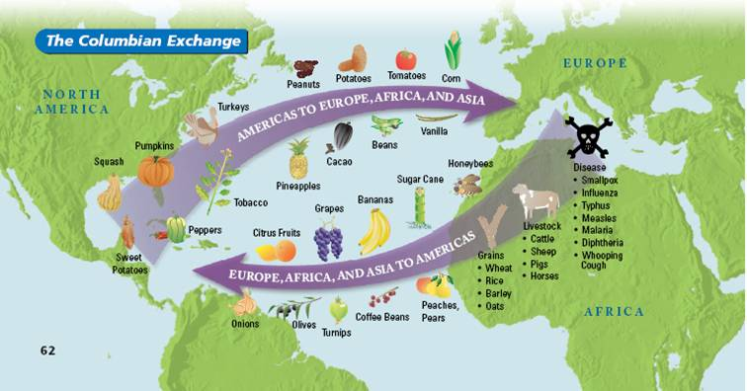
What are some conclusions that can be supported by this population pyramid?
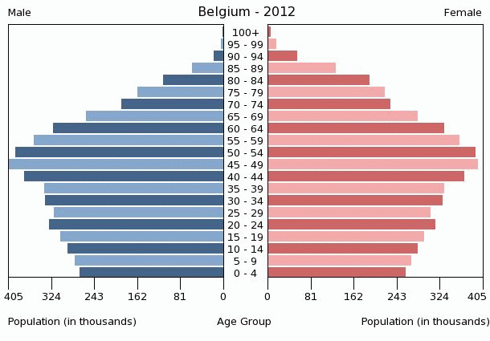

What are some conclusions that can be supported by this population pyramid?
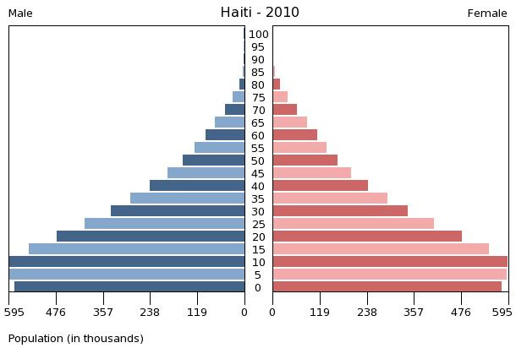

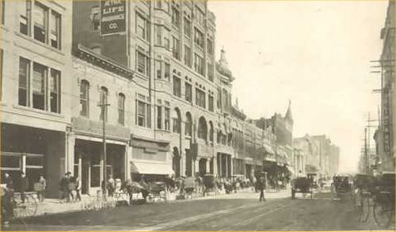
Dallas year 1900
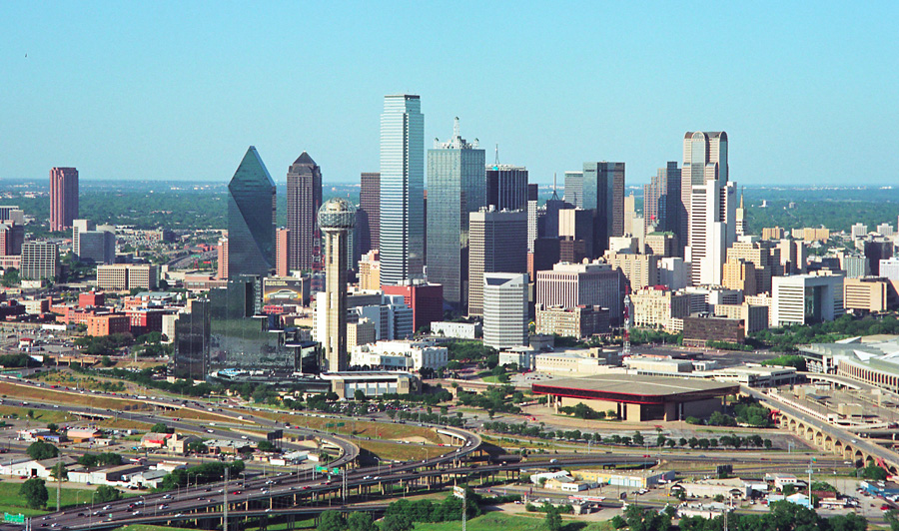
Dallas year 200
What has changed about the society in Dallas?

