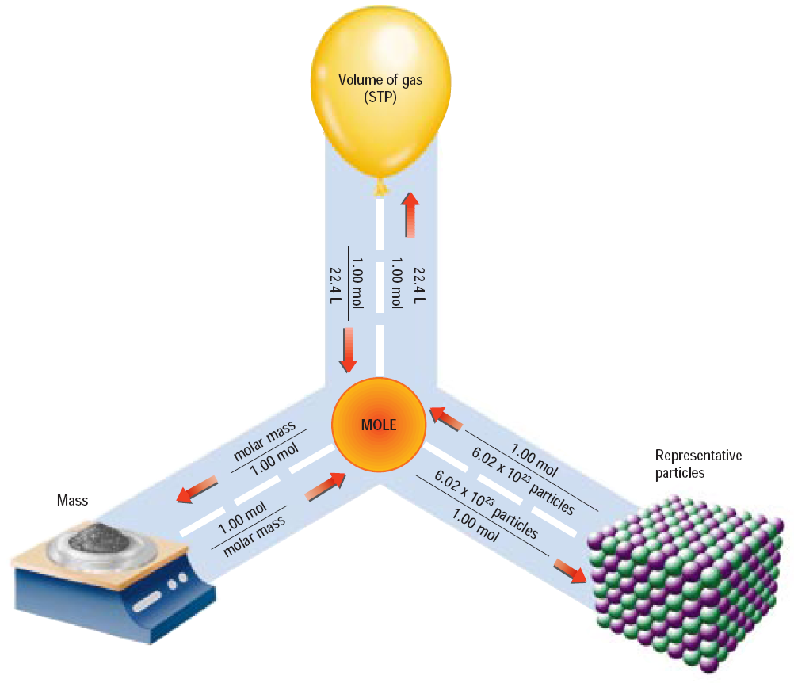

Atoms

Molecules

Ions

Formula Units



Atoms

Molecules

Ions

Formula Units