Name:_______________________________________Date:__________Class:__________Period:__________

Directions: Use the following link to complete the activity.
http://www.dentalcare.com/en-US/dental-education/continuing-education/ce104/ce104.aspx?ModuleName=overview&PartID=-1&SectionID=-1

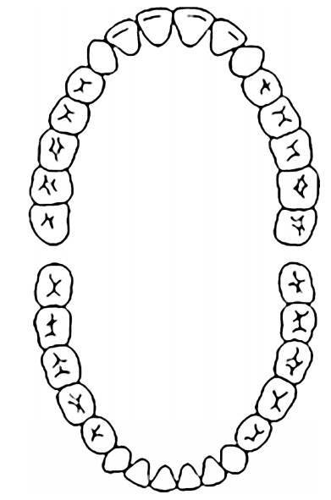

- Number each tooth according to the Universal Numbering System used in dental schools.
- Label the Maxilla arch
- Label the Mandible arch.
- Label the Posterior side of the mouth.
- Label the Anterior side of the mouth.
- Label the Mesial side of the mouth.
- Label the Distal side of the mouth.
- Label the Buccal/Facial side of the mouth
- Label the Lingual side of the mouth.
- Label the Palatal side of the mouth.
Name:_______________________________________Date:__________Class:__________Period:__________

Directions: Use the following link to complete the activity.
http://www.dentalcare.com/en-US/dental-education/continuing-education/ce104/ce104.aspx?ModuleName=overview&PartID=-1&SectionID=-1

- Number each tooth according to the Universal Numbering System used in dental schools.
- Label the Maxilla arch
- Label the Mandible arch.
- Distinguish between and label the Anterior teeth from the Posterior teeth.
- Color all Incisors blue. What is the primary function? ________________________________________
- Color all Canines red. What is the primary function? _________________________________________
- Color all Premolars purple. What is the primary function? _____________________________________
- Color all Molars green. What is the primary function? ________________________________________
- Use brackets to group and label each tooth according to the type of tooth to which it belongs.
- Label each tooth according to the name in which it was assigned. (Example: 2nd Premolar)

